**Support Vector Machines (H02D3a)**

Exercise Sessions report

Marimuthu Ananthavelu (r0652832), MAI, KU Leuven.

2016-2017.

1. **Classification**
   1. Two Gaussians

Geometric construction of a classifier line looks complicated given the data points are spread across each other. The classifying line should ideally be a decision boundary between the two classes namely ‘versicolor’ and ‘virginica. In our case, the decision boundary cannot be a straight line considering the nature of the data points which all are pertaining to two different classes. When the decision boundary separates these 2 classes with clearly indicating all the data points pertaining to ‘versicolor’ on one side and all the data points pertaining to ‘virginica’ on the other side, then we can consider that the classifier is optimal/valid.

* 1. The Support Vector Machines
     1. When adding the new data points to the vector space the following happens;
* Each additional data point gets added to the dataset
* Decision boundary adjusts itself with respect to the modified dataset and accordingly the number of iterations gets modified with respect the inclusion of data point and re-optimization.
* When the new data point is added to the extreme left or right sides of the decision boundary, the existing decision boundary changes its position drastically (making a larger difference in the positional points in the vector space) considering the new data point.
  + 1. When adding an outlier, the following happens;
* With the same given parameters of ‘C’ and ‘kernel sigma’, the decision boundary changes with respect to the new data point and the new support vector is getting added to the side opposite of the class in which the outlier is present.
  + 1. C is the parameter for the soft margin cost function, which controls the influence of each individual support vector.

Changing the C value to different values the following are the observations;

* The increase in C parameter, makes the classifier to be more accurate as possible by penalising the misclassification heavily.
* The decrease in C parameter, makes the classifier to be leaving some of the data points under the wrong class which makes the classifier less robust.
* For example, with C parameter of ‘1’, the classifier is as below;

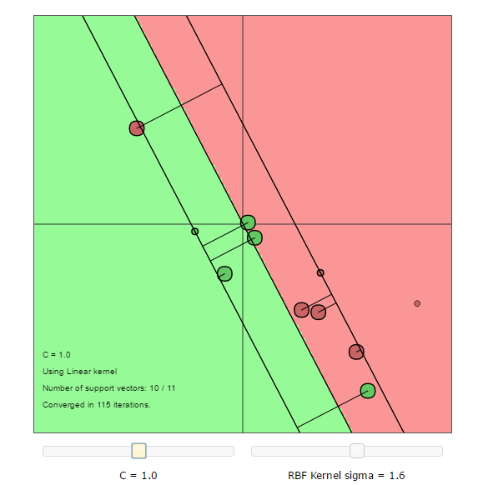

**Fig.1.Classifier with C=1**

With C parameter of ‘25’, the classifier is as below;

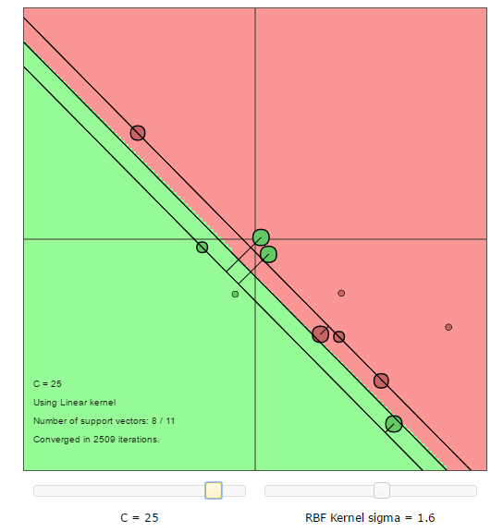

**Fig.2.Classifier with C=25**

* In Fig-1, with C=1, the classifier is not robust and classifies one or some of the data points on the wrong side of the decision boundary.
* In Fig-2, with C=25, the classifier attempts to be more robust and creates a very closely possible decision boundary especially giving importance to the data points which all are outliers.

***Using RBF kernel:***

* + 1. Switching over to RBF kernel gives the decision boundary which is not a straight line but closed over the different cluster(s) of data points. This clearly indicates that the RBF can be used for non-linearly separable data points. The classifier space looks as below;

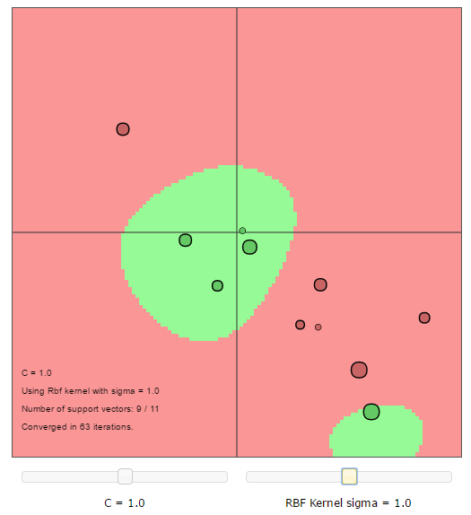

**Fig.3.Classifier using BF Kernel**

* + 1. Sigma is a parameter of the Gaussian kernel and defines the steepness of the rise around the landmark. The following changes happen with respect to the change in ‘sigma’ value.
* Increase in ‘sigma’ makes the decision boundary with stronger smoothing i.e. high bias with low variance
* Decrease in ‘sigma’ makes the decision boundary with overfitting for the chosen data points

Changing the both the hyperparameters provides the following the observations for a given kernel;

* The C Parameter implies the penalties on the misclassified data and thus higher C value provides better classified data with smooth boundaries.
* High C parameter value and low sigma value provides an optimal decision boundary
  + 1. Role of the Given Kernel, Regularization parameter, and the kernel parameter:
* Linear Kernel, is limited to classifying the data points which all are linearly separable using the straight line. They can’t be used for complex classification applications where as the linearly non-separable data are presented.
* C Parameter in both the kernels, gives an indication about smoothing of the decision boundary. The higher the value, the more penalty it awards for the misclassifying data points. The less they are, the kernel will leave some of the outliers and place the data points on the wrong side of the decision boundary.
* Sigma is applicable to the ‘RBF’ kernel function where the higher value puts the data points on the wrong side of the decision boundary whereas the small values make the decision boundary which overfits.
* In case of Linear kernel, an optimum C Parameter is required.
* In case of RBF kernel, an optimum C and Sigma parameter are required.
* Essentially *both* the kernel and regularization parameters (C) control capacity, and one can get a diagonal trough in the Cross-validation error as a function of the hyper-parameters because their effects are correlated and different combinations of kernel parameter and regularization provide similarly good models.
  + 1. Role of Support Vectors:

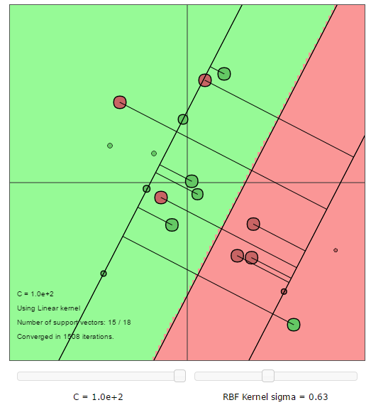

**Fig.4.Support vectors visualization**

* In the above figure, the support vectors are the points which lie along the supporting hyperplanes (the hyperplanes parallel to the dividing hyperplane at the edges of the margin). Regardless of the number of dimensions or size of data set, the number of support vectors could be as little as 2.
* When the margin becomes very wide, there are lots of support vectors.
* The number of support vectors depend upon the how much C parameter is allowed for the given distribution of the data. If large value of C parameter is allowed, then we will have a large number of support vectors and If small value of C parameter is allowed, we will have very few support vectors.
* Accuracy of our classification depends on the trade-off between a high-complexity model which may over-fit the data and a large-margin which will incorrectly classify some of the training data in the interest of better generalization. The number of support vectors can range from very few to every single data point which will completely over-fit your data. This tradeoff is controlled via C parameter and through the choice of kernel and kernel parameters.
* The support vector machine searches for the closest points which it calls the "support vectors. Support Vector Machines are an optimization problem. They are attempting to find a hyperplane that divides the two classes with the largest margin. The support vectors are the points which fall within this margin. For an example, in the following classification problem, there are 2 support vectors (one on negative side and another on positive side)

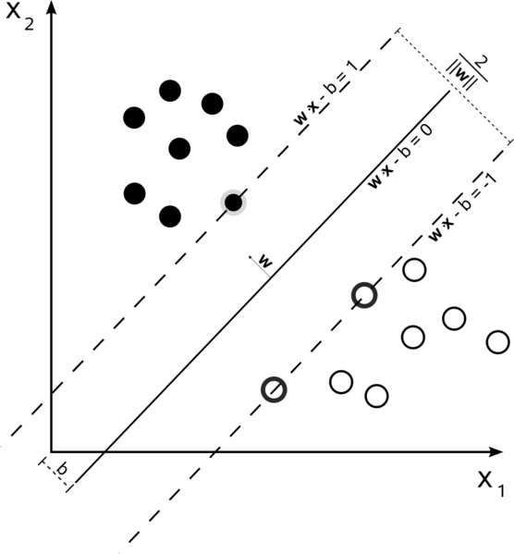

**Fig.5. Margins and Support vectors visualization**

* + 1. In the support-vectors learning algorithm the complexity of the construction does not depend on the dimensionality of the feature space, but on the number of support vectors.
* Support Vectors basically are the observations needed to define the fitted model. The more complex the model is (the more specific and overtrained), the more data points will be needed to specify the model Very few support vectors usually define a general model (with more misclassifications), while many support vectors specify a very specific model (possibly overfit). For a linear vector machine, support vectors are the observations lying within the 3margin or miss- classified. A point becomes a support vector when he he plays a role in defining the model/classification boundaries.
* Addition of more data points increases the number of support vectors normally as the decision boundary changes and accordingly, the data points on close to the margin changes.
* A Particular data point becomes support vector when it falls under or situated on the margins in the classification space.
  1. Using LS-SVMlab

1. The performance on the given test set for iris dataset using the linear (kernel) function is as below:

*#misclass = 11, error rate = 55.00%*

When changing the kernel to polynomial with varying degree of polynomials, the misclassifications and the error rates are as below;



**Fig.6. Polynomial kernel – Misclassification and Error rate**

The observations when increasing the degree of polynomial have similar impacts as the value of Sigma decreases. The increased polynomial makes the classifier to separate the non-linearly separable data points using the curvature/quadratic based decision boundary.



**

1. **With increased number of sigma2 , the error plot shows that, the number of misclassified data points are decreasing.

**Fig.7. Polynomial kernel effects of degree of increase**

**

**Fig.7. Polynomial kernel effects of degree of increase**

1. With fixed Sigma2 value and varying gamma values, the number of misclassifications are as below;



**Fig.8. Effect of gamma values**

* A Good range of gamma values starts from ~0.05. Below this value, the contour plot is finding a matrix with the same value everywhere and doesn't have any level change, so no contour could be drawn.
* When the gamma value is increased further (500 in our case for the given data set and the parameter settings), the decision boundary becomes 2 instead of original one. Now the misclassified data points are also increased (from 0 to 1). Thus, the maximum parameter value in this case is preferred to be less than 500. This is visible as below;

**



**Fig.9. Effect of gamma values -Misclassification**

* + 1. The Choice of hyper parameters:

Performance in terms of misclassification on the validation set:



**Fig.10. Effect of hyper parameters**

* With less value of sigma2 over the range of gamma parameters, the number of misclassified data points are still less.
* When the sigma2 increases above the 4 and for the value of gamma under 50, the there is a misclassified data point(s).
  + 1. ***Cross validation:***

Cross validation is a method for estimating the predictive accuracy of the Model and a way to ensure that the classifier learns fair in for unseen data. This is done by splitting the dataset by training and validation data in successive combinations keeping validation data as different each time.

For example:

Step 1 : Splitting the total data set into 10 (most times uniform) sets. Let’s say K=10

Step 2 : Consider 1 set as validation set with remaining (K-1) sets for training the model

Step 3 : Choose a different set now and keeping the remaining sets for training the model

Step 4 : Step 2 and 3 makes all the sets of data (different samples in the population) to train the model.

The above Cross validation procedure ensures the model is fair for any unknown new dataset.

Optimization algorithms like grid search, is useful when the parameters are not learned within the estimators, so that it can be set by Grid search by considering the given range of parameters.

Simple validation procedure, has the parameters optimized and having been trained for one set of validation set in the whole dataset. So, it might not generalize well to the data which the model had not seen before and might overfit to the given set of data.

In case of Cross validation (10 times here for example), the validation set changes every time so the model has adjusted its hyper parameters with respect to change in the different validation points. In the latter case, the model can be said it is very generalized.

The performance for the crossvalidate and singleoneout are as below;

|  |  |
| --- | --- |
| Method | performance |
| crossvalidate | 0.05 |
| singleoneout | 0.06 |

**Table-1. Performance comparison between cross validate and singleoneout**

Preference of ‘crossvalidate’ or singleoneout:

* Leave one out cross validation looks better when there is a small set of training data. In this case of small data set, one can't make 10 folds to make predictions on using the rest of your data to train the model.
* With the large amount of training data on the other hand, 10-fold cross validation would be a better bet, because there will be too many iterations for leave one out cross-validation, and considering these many results to tune your hyperparameters might not be such a good idea.
* There is always a bias-variance trade-off between doing leave one out and K fold cross validation. In leaveoneout cross validation, we get estimates of test error with lower bias, and higher variance because each training set contains n-1 examples, which means that we are using almost the entire training set in each iteration. This leads to higher variance too, because there are chances of overlap between training sets, and thus the test error estimates are highly correlated, which means that the mean value of the test error estimate will have higher variance.
* The opposite is true with k-fold CV, because there is relatively less overlap between training sets, thus the test error estimates are less correlated, and because of which the mean test error value won't have as much variance as leaveoneout cross validation.
  + 1. Comparison of different techniques for the optimizing the hyperparameters shall be below:

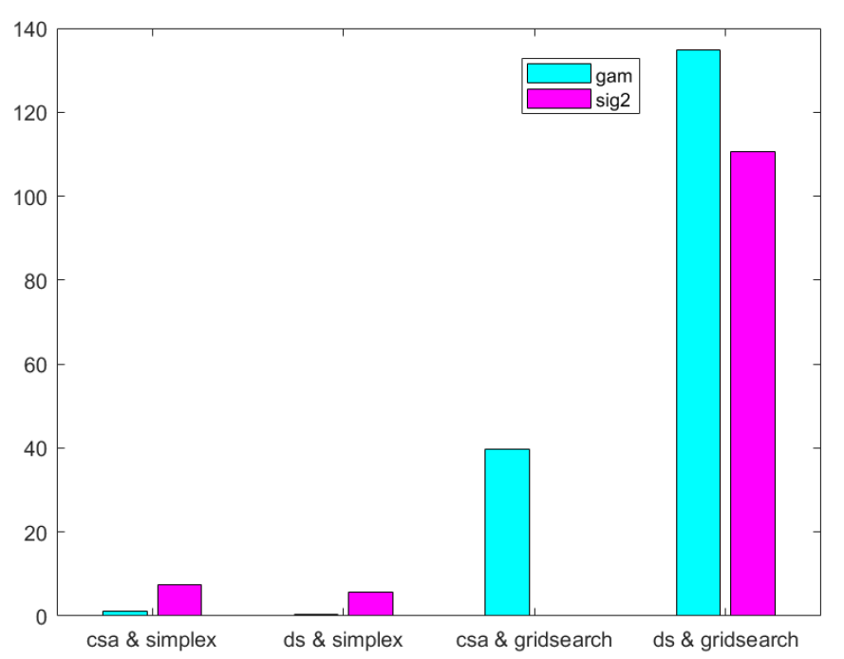

**Fig.11. Comparison of optimization techniques for hyperparameters**

* + 1. Receiver Operating Characteristic (ROC):



**Fig.12. Receiver operating characteristic curve(ROC) curve**

The receiver operating characteristic curve(ROC) curves feature true positive rate on the Y axis, and false positive rate on the X axis. This means that the top left corner of the plot is the “ideal” point - a false positive rate of zero, and a true positive rate of one. This is not very realistic, but it does mean that a larger area under the curve (AUC) is usually better. Since the generalization of the model depends upon how the testing set performs with the model, the ROC curve is useful for the testing data set.

* 1. Homework Problems
     1. The Ripley Data-set
        1. Plotted data:

Plotted data shows that there are classes which are not clearly separated whereas the data points are located in other side of the classification space.

* + - 1. Training with Linear kernel:

For a given dataset with the following spread of positive and negative classes in the vector space, the number of misclassifications and the error rate as follows;

*on test: #misclass = 36, error rate = 14.40%*



**Fig.13. Plotted space and Linear Kernel for Classification**

* + - 1. **With RBF Kernel;**

With RBF kernel and the parameters of gamma=1, sigma2=20, the classification is not linear but still accounts misclassification errors.

*on test: #misclass = 35, error rate = 14.00%*

Though there are reduced misclassifications, there are still errors exists.

***Tuning the parameters:***

With the help of ‘tunelssvm’ method, the following are the optimized parameters over the 20 different runs.





***Fig. run id vs gamma***

***Fig. run id vs sigma2***



**Fig.14.Optimization of parameters over the run**

***Fig. run id vs classification error***

***Observations from the RBF kernel optimization:***

For a given ripley data set, the optimization parameters vary as below:

* Gamma varies from 0 to 140
* Sigma2 varies from 0 to 2
* Classification errors accordingly vary from 14% to 25%.
* The lowest classification error of 14% comes with gamma value of 40 and sigma2 value of 1.5.
* The highest classification error of 25% comes with gamma value of 5 and sigma2 value of 0.1.
* It is evident from the above observations that, the lowest gamma and sigma2 values misclassify more examples than other combination of these parameters.
  + - 1. *Receiver Operating Characteristic Curve:*

As predicted, there is more false positive rate for linear model whereas the RBF kernel shows reasonably more true positives. This can be seen below:

 **

***Fig.15 ROC for Linear and RBF kernels***

* + 1. Breast Cancer Dataset
       1. Plotting the dataset

Plotting the given variables are done individually as the number of features are 30. Some of the plots are as below;

Matrix of scatter plots by group for some of them:

***Fig.16 visualization of data points***



***Fig.17 Combination of set wise visualization***



***Fig.18 run-id vs hyperparameters***





***Fig.19 Hyperparameter vs run, ROC’s for linear and RBF kernels***

* + 1. Diabetes Database

Similar to the above dataset, this best performance on the highly non-linear vector space,kernel functions perform better than linear kernel.





***Fig.20.a visualization of data points***











***Fig.20b Hyperparameters vs run, ROC’s for linear and RBF kernels***

**2.0 Function Estimation and Time- series Prediction**

For this exercise, the SVM toolbox is used.

**2.1 The Support Vector Machine for Regression**

A artificial data has been created with the help of 20 different data points using the User interface ‘uiregress’. We start by adding 20 points to the user interface. For the chosen data points the added points output the polynomial function of degree 2. And by creating a different dataset using different interface, with different types of kernels.

In the following figures, we display the results for linear, polynomial (degree 2), RBF and linear B-Spline (degree 2). Although theoretically, a polynomial kernel of degree 2 would be the best, we see that other kernels (RBF and linear B-Spline) perform similarly. However, the B-Spline kernel overfits the data.

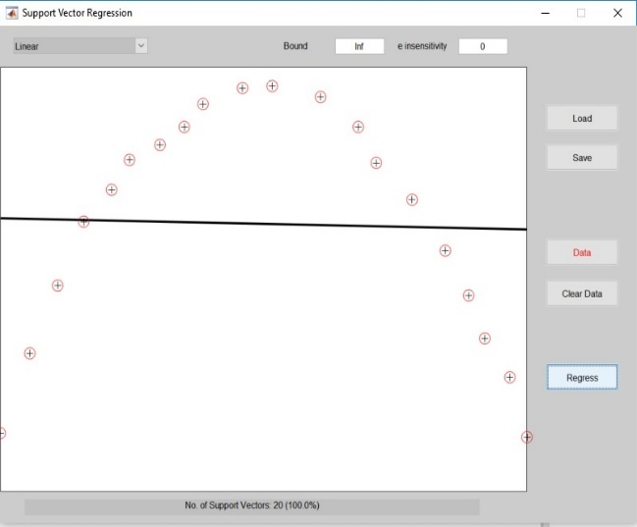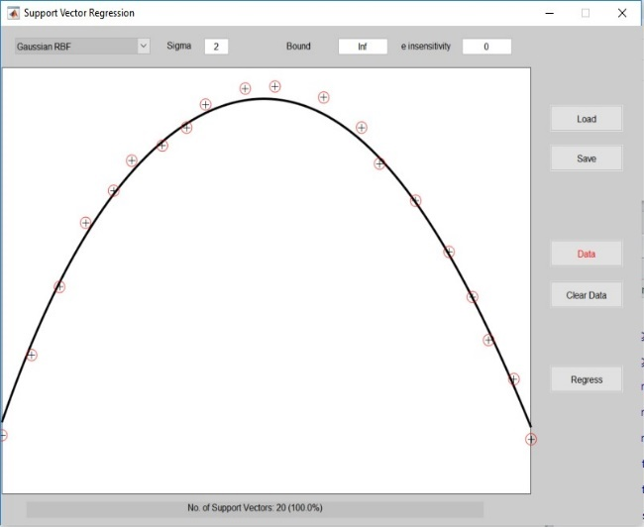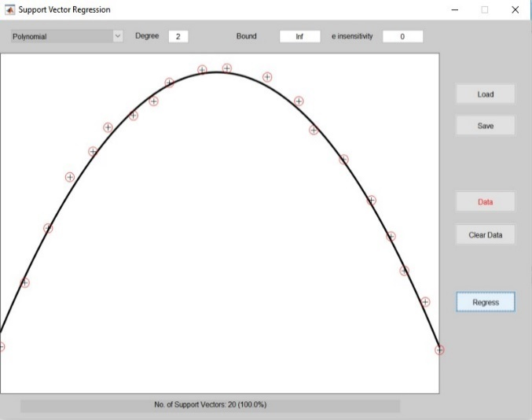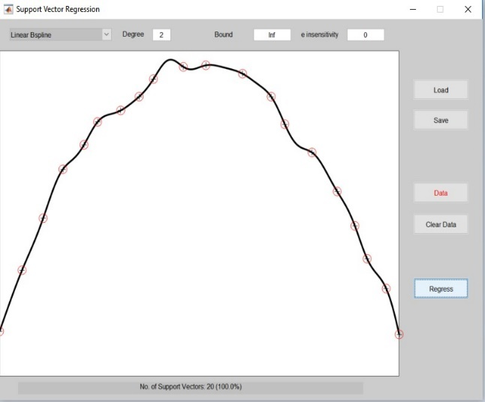

**Fig-1- Regression results for linear, polynomial, RBF and linear B-Spline kernels**

Figure 2 depicts a comparison of a linear and RBF kernel on approximately linear data. but for linear data with noise, a linear kernel will deliver a better performance on unseen samples, as RBF or more complicated kernels will clearly overfit the data.

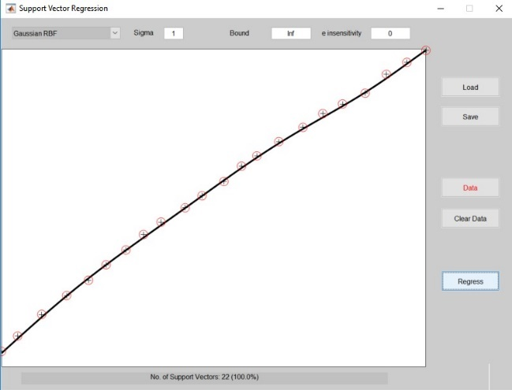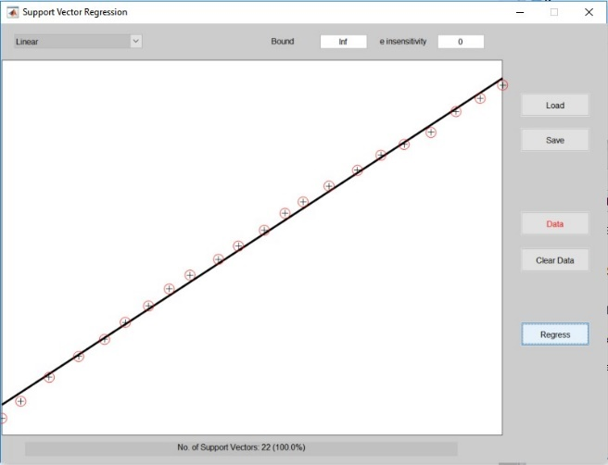

Figure 2: Comparison of linear and RBF kernels on approximately linear data

Both parameters (Bound and e) have an influence on the **flatness** of the regression curve. Figures 3 and 4 show a linear kernel on linear data for increasing values of e and Bound.

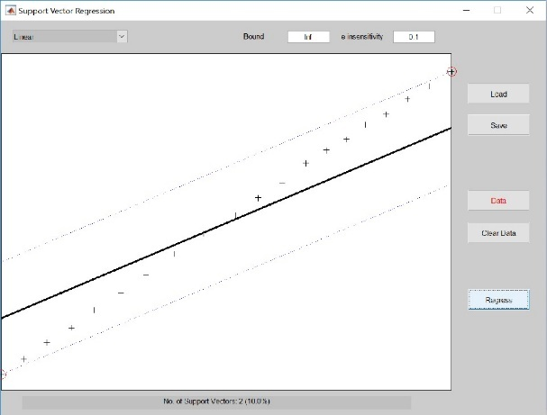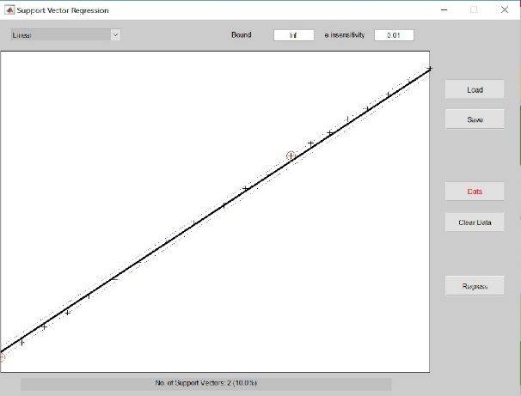

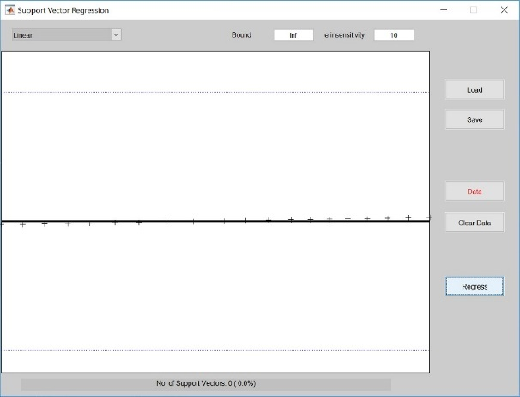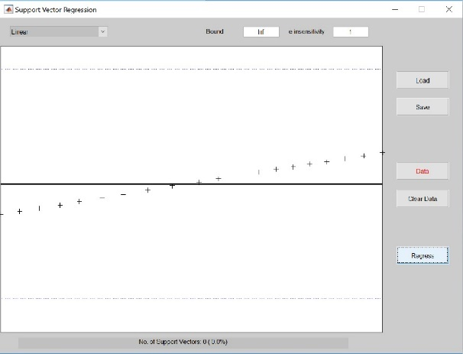

Figure 3: Linear kernel for increasing values of e, e.g. 0.01, 0.1, 1, 10 (Bound=∞)

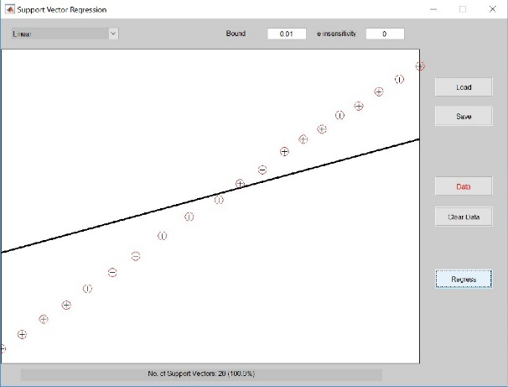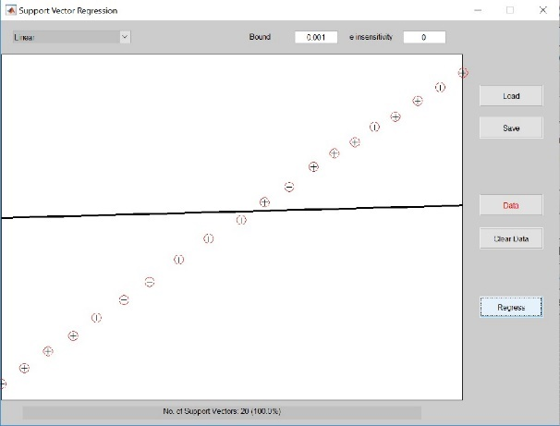

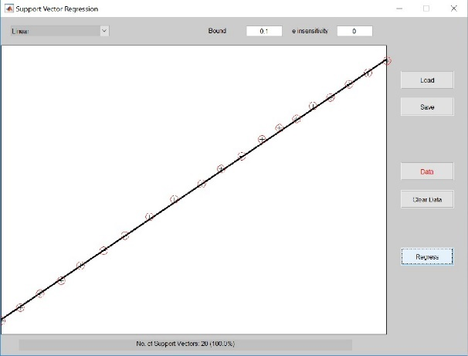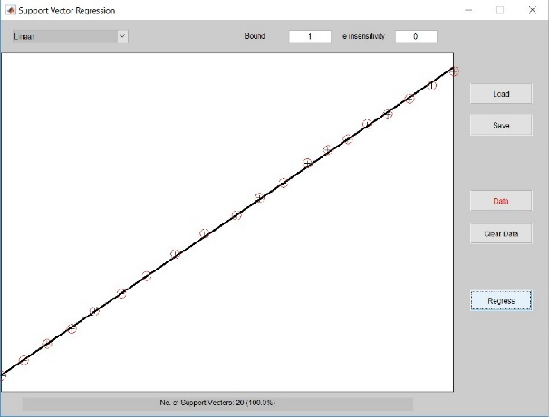

**Figure 4: Linear kernel for increasing values of Bound, e.g. 0.001, 0.01, 0.1, 1 (e=0)**

Parameter e controls the width of the e-insensitive zone (related to the loss function), used to fit the training data. The higher e, the higher the number of data points that have loss function equal to 0. Therefore, the value of e affects the number of support vectors used to construct the regression function (points for which loss function is not 0). The higher e, the fewer support vectors are selected. High values of e result in more flat estimates. Low values of e result in more accurate estimate on the training set. e must therefore be chosen to reflect the data in some way. Choosing a too low e might result in overfitting, while choosing a too high e might result in a too general (too flat) model.

Parameter C (Bound) determines the trade off between the model complexity and the degree to which deviations larger than e are tolerated in the optimization formulation. For example, if C is too large (infinity), then the objective is to minimize the empirical error only (error on the training set), without regard to model complexity.

Sparsity comes in for non-null values of e ( in the equations below). In the formulation of the optimization problem of SVM regression, the Lagrange multipliers of the dual problem vanish (they have to equal 0 for a solution to exist, linked to the KKT conditions) for the points within the e-insensitive zone. Therefore, sparsity appears as some Lagrange multipliers equal 0 and not all points are needed to characterize the regression function. The points associated to the non vanishing coefficients are called Support Vectors.

The general formulation (Vapnik) of SVM regression is as follows:

For training data {xi, yi}Ni=1 map a linear function in the feature space such that y**w**(xi) =

i=1

**w**T φ(xi)) + β0.

From the structural risk minimization principle, the formulation can be rewritten as a minimization problem:

subject to

1 T

minw,ξ 2 w

w + c

N

X

i=1

ξi (1)

yi − y**w**(xi) ≤ + ξi, i = 1, ..., N and ξi ≥ 0, i = 1, ..., N (2)

where ξi is a slack variable and the parameter defining the loss function. For least squares SVM regression, the minimization problem is written by:

1 T

minw,β0 ,e 2 µw

such that yi = y**w**(xi) + ei, i = 1, ..., N .

1

w + 2 γ

N

X

i=1

e2 (3)

i

We can rewrite e2 by (yi − (wT φ(xi) + b))2 so that the above minimization can be rewritten

i

by

1 T

minw,β0 ,e 2 µw

1

w + 2 γ

N

X

i=1

(yi − (wT

φ(xi) + b)2), (4)

which implicitly corresponds to a least squares fit regression (without the first part). Compared to the more general support vector regression framework, the least square fit does use all the points to fit the regression, while SVM regression leads to a sparse solution where only a limited number of support vectors determines the fit.

**2.2 A Simple Example: The sinc**

In this section, We simulate a cardinal sine function with noise and we train using RBF kernel in order to approximate the function. We use a training and a test set. We train the model for arbitrary values of γ (100) and σ2 (1) and visualize the results in the following figure.

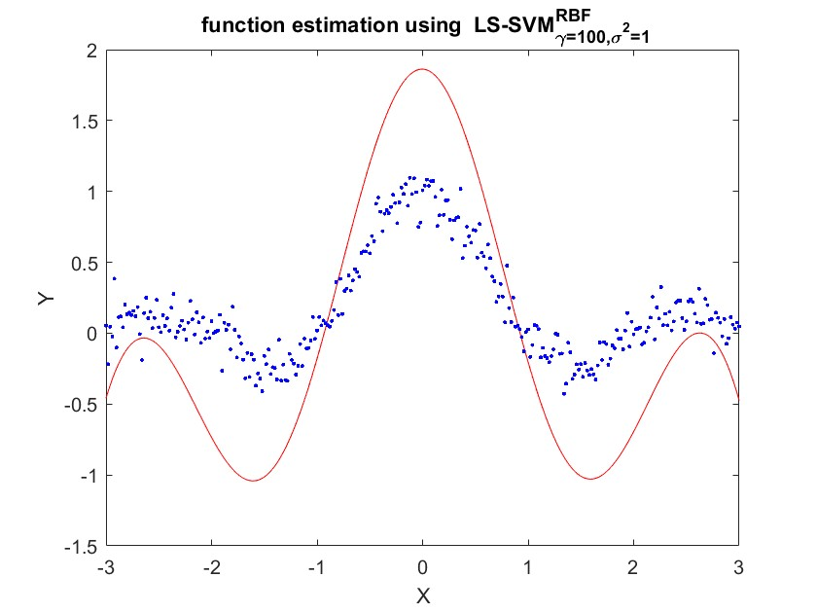

Figure 5: RBF kernel for regression on the training set

The results of applying the trained model on the test set are calculated and visualized on

Figure 6.

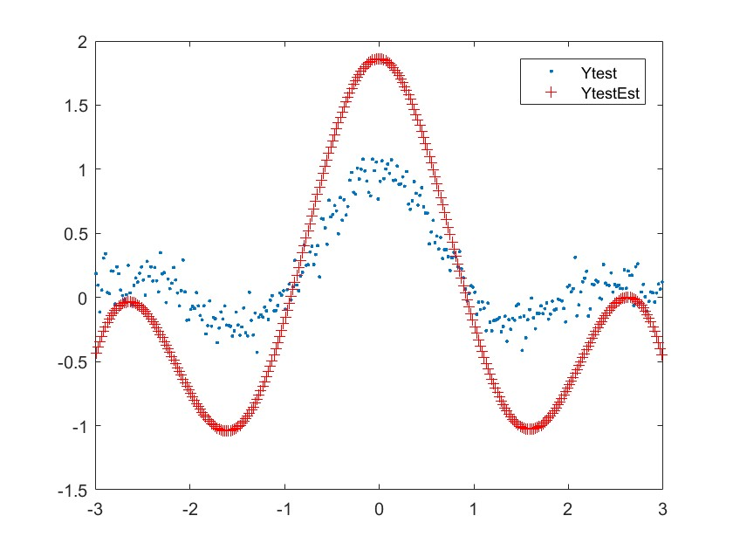

Figure 6: RBF kernel for regression on the test set

We have used arbitrary values of the hyper parameters. We also run a function estimation for a range of values for γ and σ2 and the following Figures highlights the estimated functions for 6 cases on the training and the test sets. It is obvious that it is possible to optimize the parameters according to a certain criteria so that the function estimated is the closest from the true function. However, as the hyper-parameters are continuous, there might be an infinite numbers of cases leading to similar mean squared error.

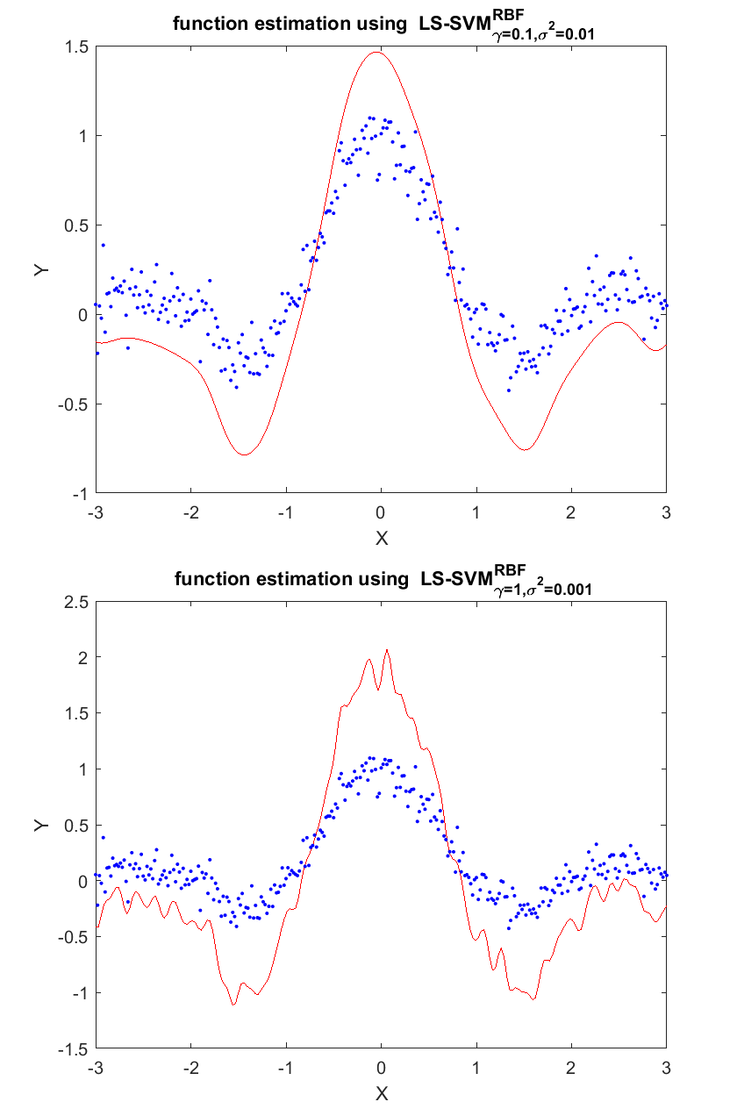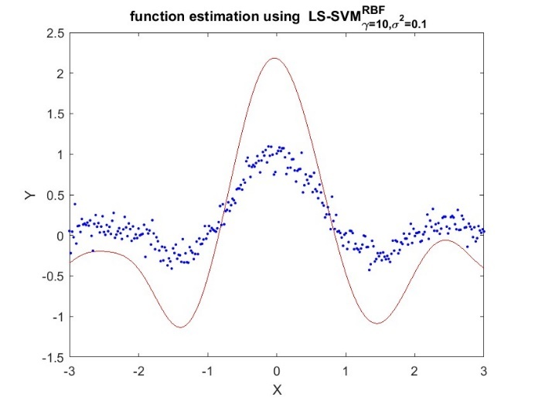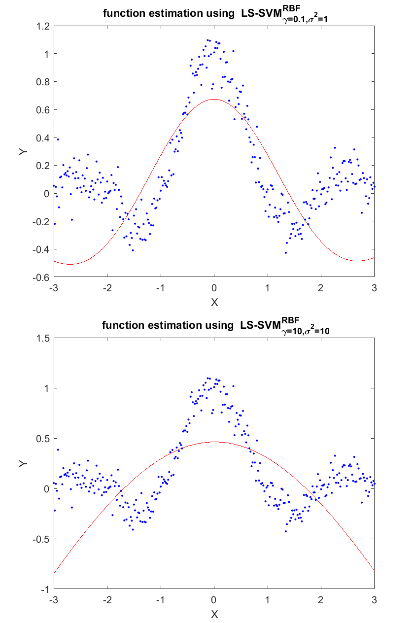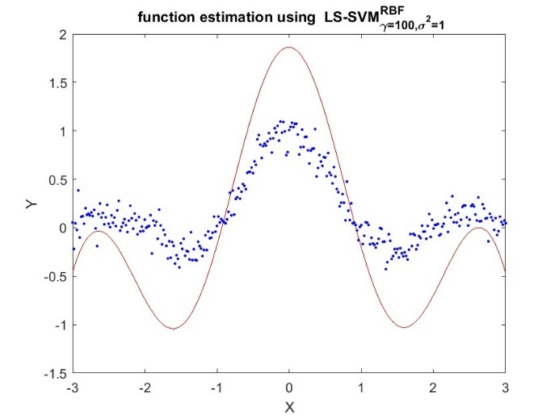

Fige 7: RBF kernels for different values of γ and σ2 on the training set

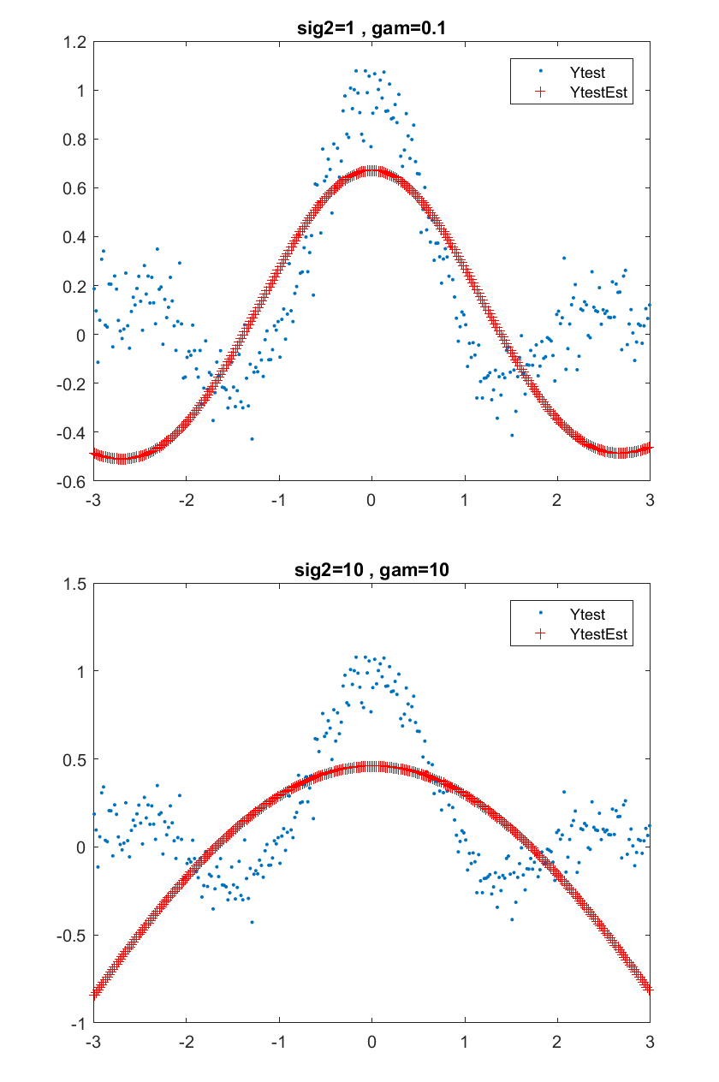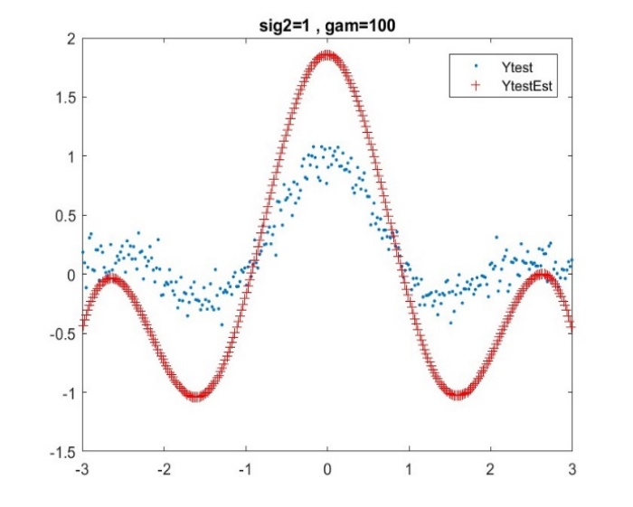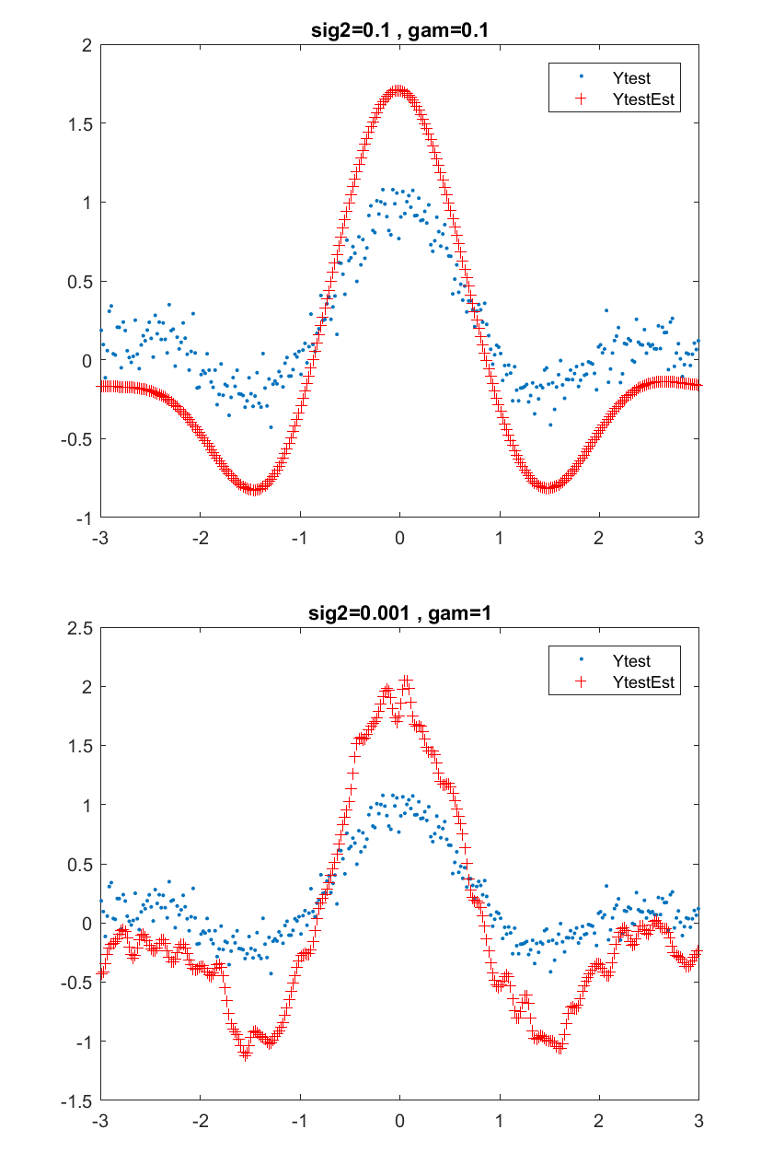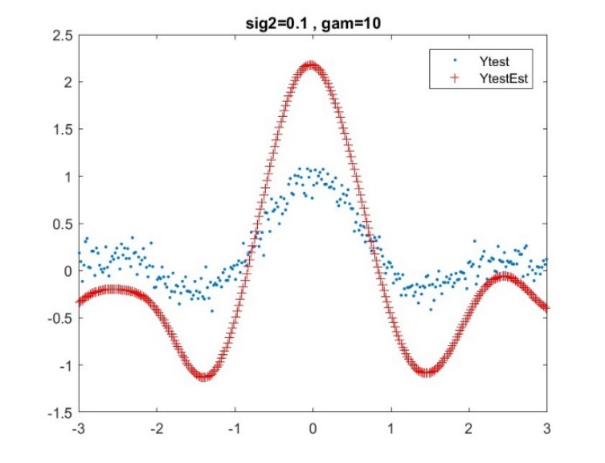

**Figure 8: RBF kernels for different values of γ and σ2 on the test set**

**2.3 Hyper-parameter Tuning**

In this section, we study the tuning algorithm used to optimize the parameters of the RBF kernel (Figure 8). We run the tuning algorithm several times and compare the obtained values of the hyper parameters. This is depicted in Figure 5.

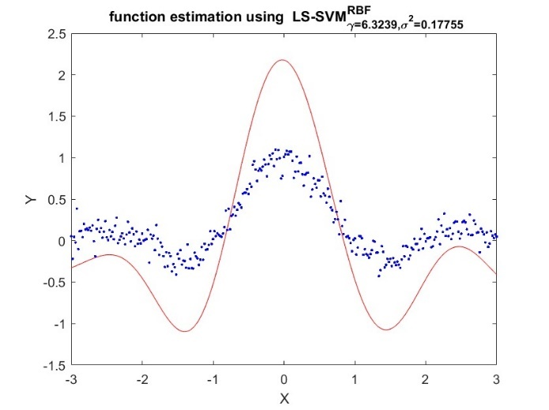

Figure 9: Optimized estimated function (gridsearch)

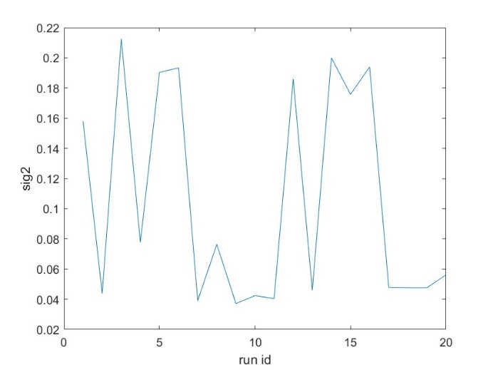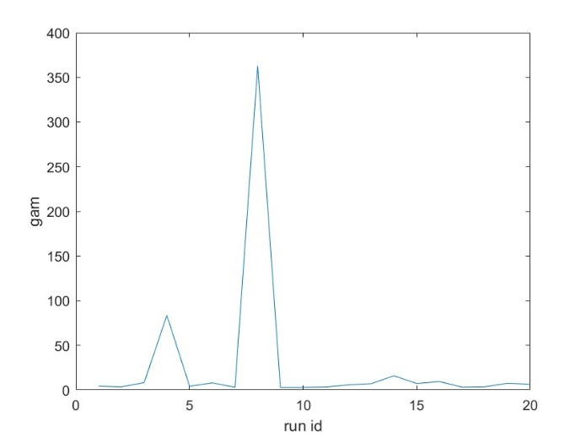

Figure 10: Optimized values of γ and σ2 when running the tuning algorithms several times

(gridsearch)

We observe that the estimated optimal parameters change a lot from one run to another but have little influence on the cost of the hyper parameters (Figure 10). We also observe that although optimal parameters can change, the estimated regression doesn’t vary a lot (Figure11).

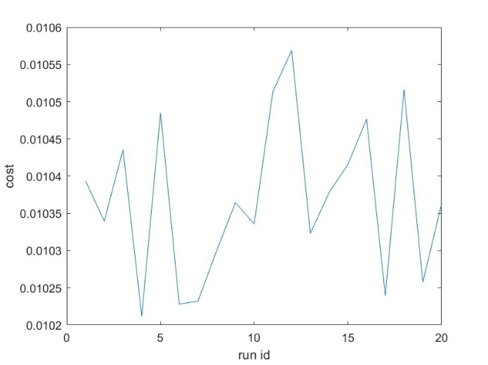

Figure 11: Cost of hyper parameters when running the tuning algorithms several times

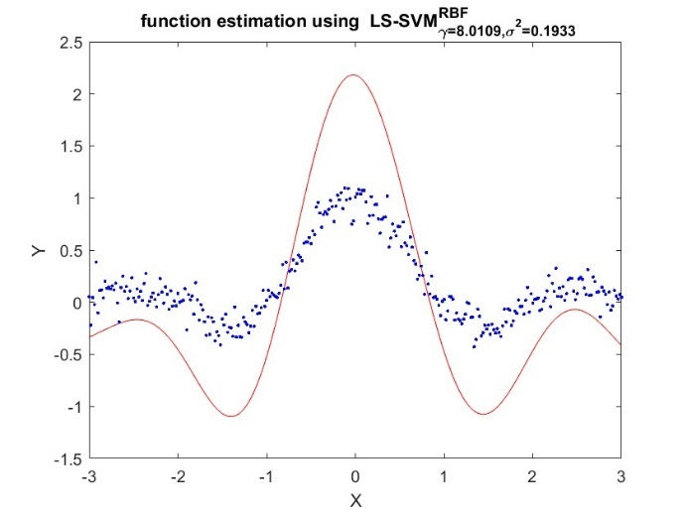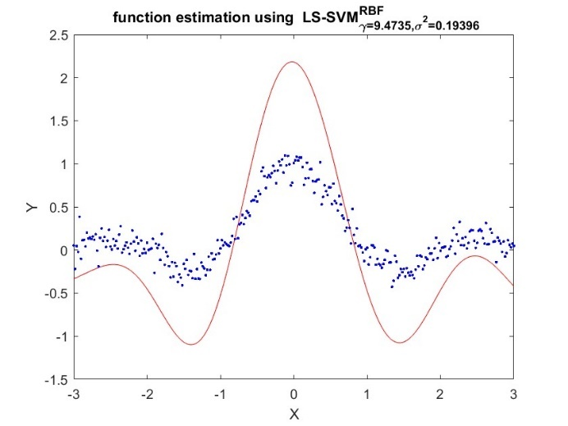

(gridsearch)

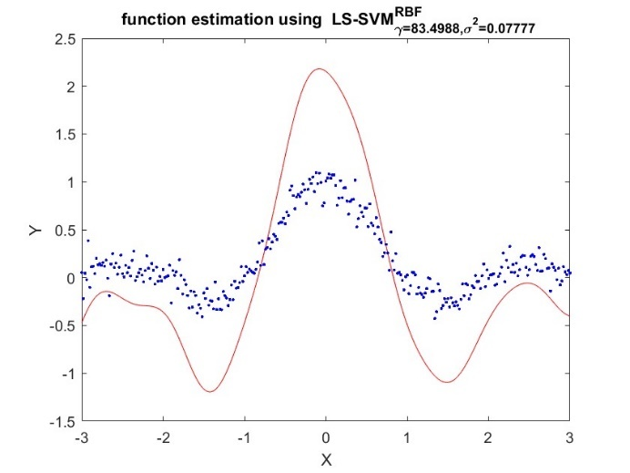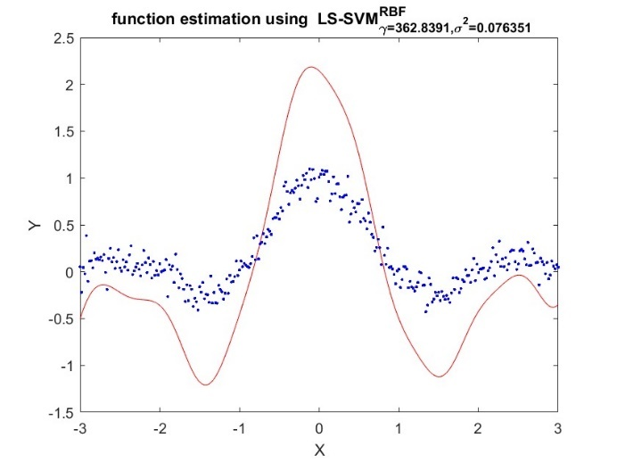

Figure 12: Estimated function when running the tuning algorithm several times (gridsearch)

When we change the optimization procedure in the tuning function to simplex and re-estimate the optimal model, we obtain the following result.

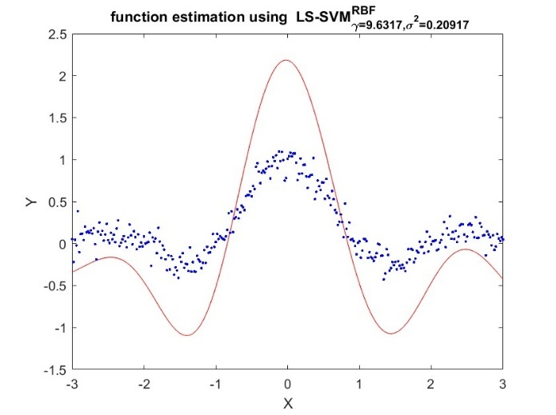

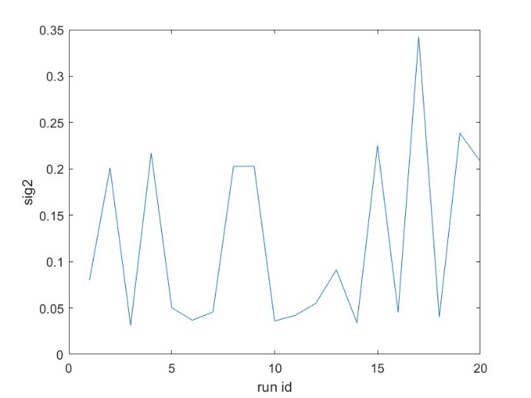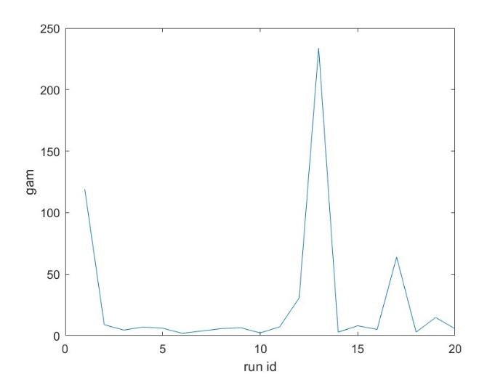Figure 13: Optimized estimated function (simplex) Again, we run the tuning algorithm and obtain the following pictures.

Figure 14: Optimized values of γ and σ2 when running the tuning algorithms several times (simplex)



Figure 15: Cost of hyper parameters when running the tuning algorithms several times

(simplex)

Again, optimized values vary heavily, but the estimated functions are very similar. For a given starting point (calculated based on csa), gridsearch exhaustively considers all parameter combinations for a grid around the starting point. The start-values determine the limits of the grid over parameter space. The Nelder-Mead method or downhill simplex method is a commonly applied numerical method used to find the minimum or maximum of an objective function in a multidimensional space. It is applied to nonlinear optimization problems for which derivatives may not be known. The method uses the concept of a simplex, which is a special polytope of n + 1 vertices in n dimensions. The method approximates a local optimum of a problem with n variables when the objective function varies smoothly and is unimodal.

**1.4 Application of the Bayesian Framework**

The Bayesian framework now can be used to tune and to analyze the LS-SVM regressor. The basic result from the Bayesian framework for the LS-SVM is the derivation of the probability that the data points are generated by the given model. This is called the posterior probability. This probability criterion is expressed as a number. There are 3 variants: the posterior with respect to the model parameters α and b, the posterior with respect to the regularization constant and the posterior with respect to the choice of the kernel and its parameter.

This three-levels principle can be schematized by the following picture: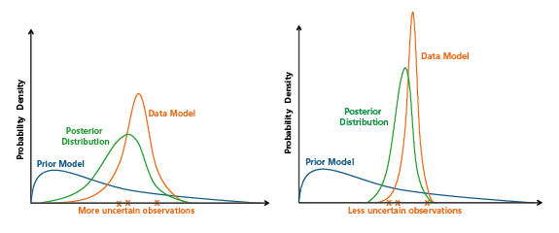

**Fig-Schematic of a Bayesian "update" of a prior model from a data model describing the observations as relatively uncertain (left panel) and relatively certain (right panel), resulting in posterior distributions with more and less uncertainty, respectively.**

Provided data set D, a model H with parameter vector w and so-called hyper-parameters or regularization parameters θ, Bayesian inference is constructed with 3 levels of inference:

• In level 1, for a given value of θ, the first level of inference infers the posterior distribution of w by Bayesian rule:

p(w | D, θ, H ) ∝ p(D | w, H )p(w | θ, H ) (5)

• The second level of inference determines the value of θ, by maximizing

p(θ | D, H ) ∝ p(D | θ, H )p(θ | H ) (6)

• The third level of inference in the evidence framework ranks different models by examining their posterior probabilities:

p(H | D) ∝ p(D | H )p(H ) (7)

For regression, the error bars can be computed using Bayesian inference (see Figure 17)

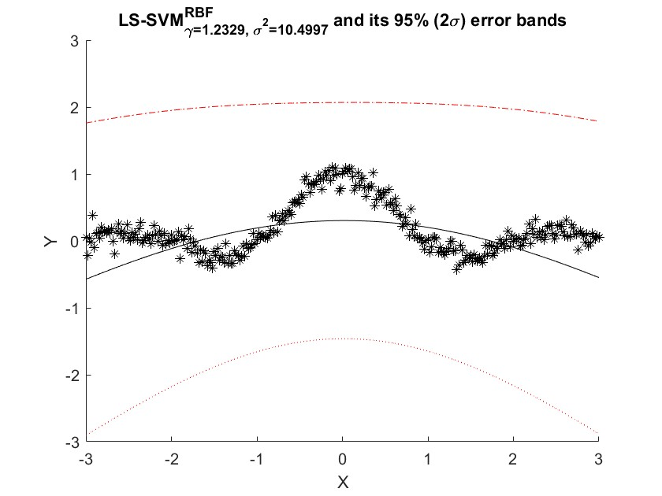

Figure 17: Error bars for Bayesian inference

For classification, it is also possible to get probability estimates. We load the Iris data-set and calculate the posterior class probabilities. Results are displayed at the following figure:

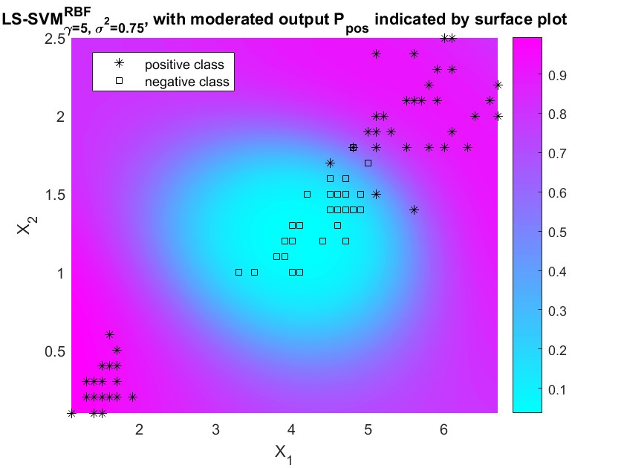

Figure 18: Posterior class probabilities

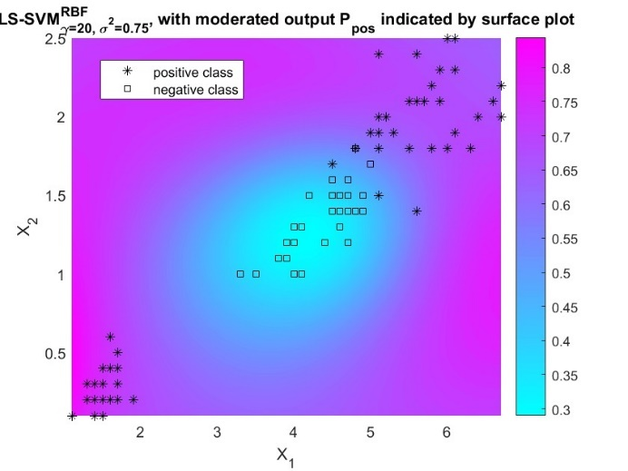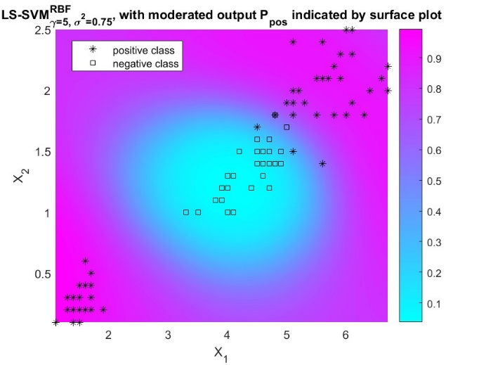

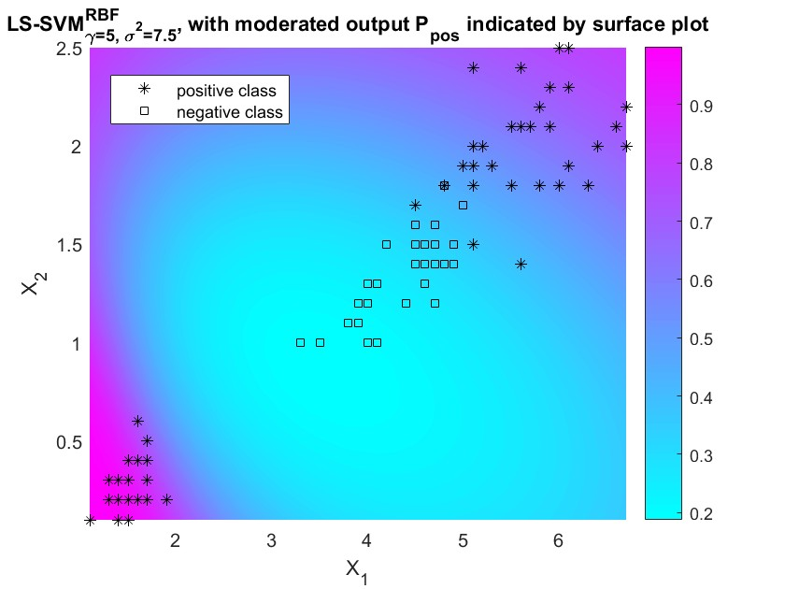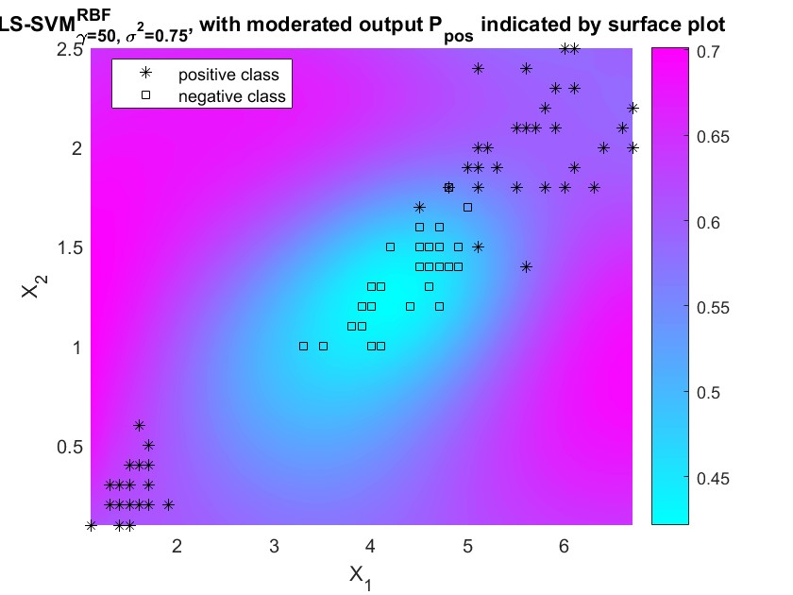

**Figure 19: Posterior class probabilities for different values of the hyper-parameters**

Colors represent the probability that a point belongs to the positive class. Figure 19 represents the same probabilities when we change the values of the hyper-parameters. Obviously, for different values, the probabilities change. As the values move away from the optimal values, we can observe that the obtained posterior probabilities don’t match the empirical labels.

The Bayesian framework can also be used to select the most relevant inputs by Automatic Relevance Determination (ARD). In a backward variable selection, the third level of inference of the Bayesian framework is used to infer the most relevant inputs of the problem. Only the most explanatory variables will be selected.

ARD assigns a different weighting parameter to each dimension in the kernel and optimizes this using the third level of inference. Per the used kernel, one can remove inputs corresponding the larger or smaller kernel parameters. In each step, the input with the largest optimal σ2 is removed (backward selection). For every step, the generalization performance is approximated by the cost associated with the third level of Bayesian inference.

An easy way to represent the results is to plot the cost associated with third level of inference for each feature (Figure 20). Features 1 and 3 have the higher cost (the generalization performance is approximated by the cost associated with the third level of Bayesian inference.) and are therefore selected.

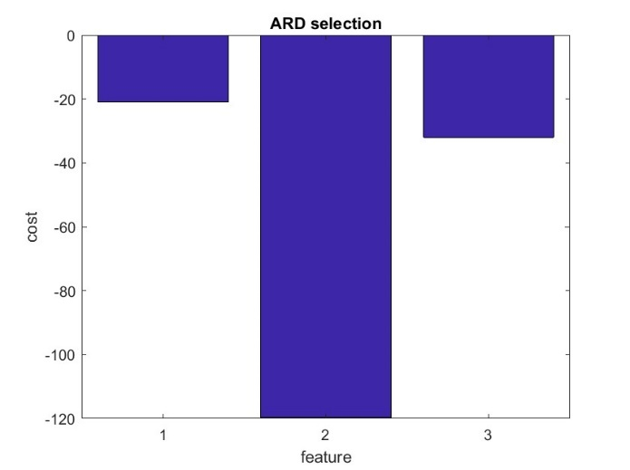

Figure 20: ARD selection

Cross-validation can be used instead of the Automatic Relevance Determination. Selecting each possible combination of variables, tuning the hyper-parameters and calculating the cost function of the cross-validation procedure leads to the same result (selecting the number of variables that correspond to the lowest cost function of the cross-validation procedure). To fully mimic the backward selection procedure, we can start with all possible variables, exclude sequentially only one variable, select the model that correspond to the lowest cost and start again the backward procedure.

**1.5 Robust Regression**

In this section, we study the impact of outliers on the regression. In situations where the data is corrupted with non-Gaussian noise or outliers, it becomes important to incorporate robustness into the estimation.

The Figure 21 highlights the impact of outliers on the estimation of the regression.

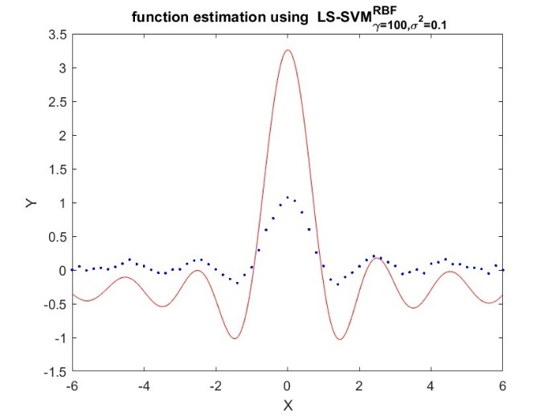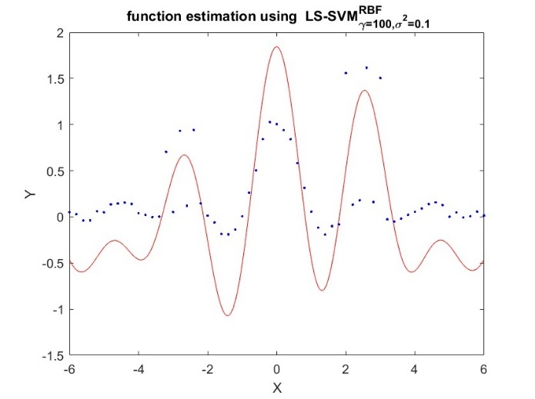

Figure 21: Regression with outliers (left) and without (right)

Outliers impact the regression locally (where outliers are). Learning observations with outliers without awareness may lead to fitting those unwanted data and may corrupt the approximation function. This will result in the loss of generalization performance in the test phase.

Outliers are dealt with in SVM regression by using robust cross-validation and smoothing the impact of outliers. Figure 22 shows the result of a robust cross-validation and the use of a smoothing function for the outliers. We can see that the outliers don’t impact the regression anymore (or at least to a lesser extent).

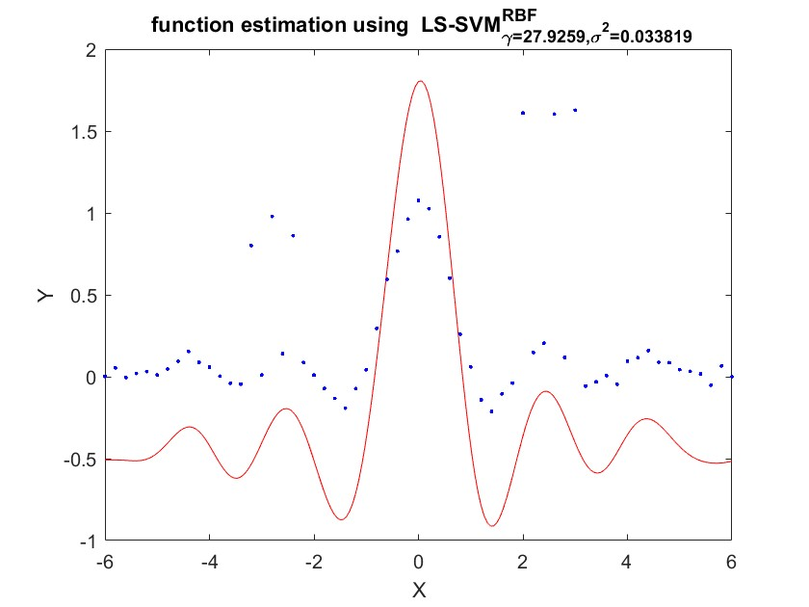

Figure 22: Robust cross-validation and outliers smoothing

Both mean squared error (MSE) and mean absolute error (MAE) are used in predictive modeling. MSE has nice mathematical properties which makes it easier to compute the gradient. However, MAE requires more complicated tools such as linear programming to compute the gradient. Because of the square, large errors have relatively greater influence on MSE than do the smaller error. Therefore, MAE is more robust to outliers since it does not make use of square.

Different weighting functions can be used in robust regression. Figure 23 describes the four weighting functions available with the tuning algorithm for robust regression. As an example, the weighting function Hampel completely ignores points further than a certain threshold (b2).

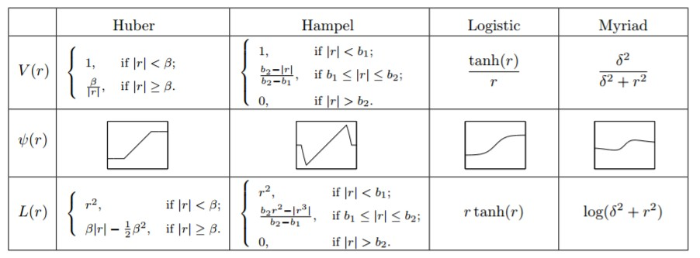

Figure 23: Weighting functions for robust regression

The following figure represents the results of different weighting functions for robust regression (top-left

= Huber, top-right = Hampel, bottom-left = Logistic, bottom-right = Myriad). Comparison of the results of the different weighting functions is made difficult due to the instability of the tuning algorithm (optimal values are different every time).

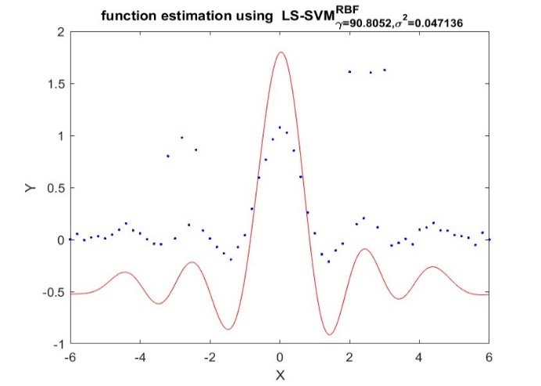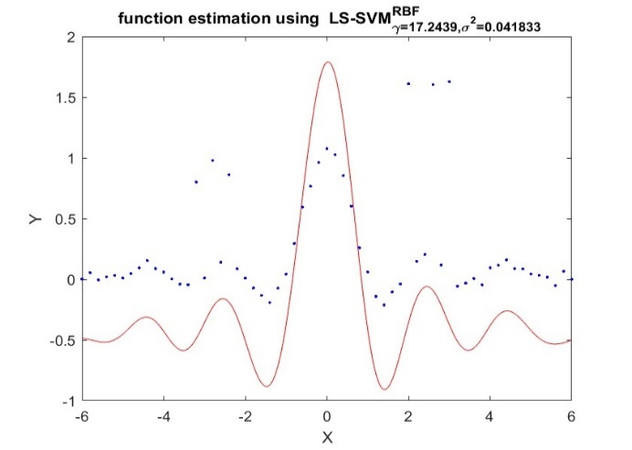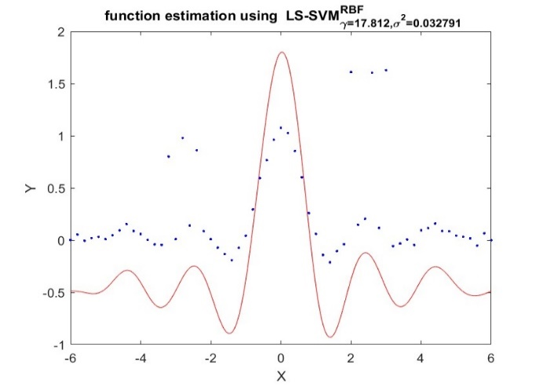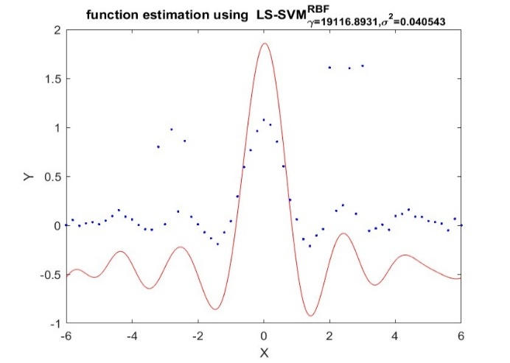

Figure 24:Results of different weighting functions for robust regression

**2.6 Homework Problem**

2.6.1 Introduction: Time-series Prediction

In this section, we investigate the use of SVM regression for time series model. The linear auto-regressive (AR) model of a process Zt with t = 1, 2, ..., ∞ is given by

z˜t = a1zt−1 + a2zt−2 + ... + anzt−n (8)

with ai ∈ R for i = 1, ..., n and n the model order. The nonlinear variant (NAR) is described as:

z˜t = f (zt−1, zt−2, ..., zt−n) (9)

The time-series identification can be written as a classical black-box regression modeling problem:

y˜t = f (xt) (10)

with yt = zt and xt = [zt−1, zt−2, ..., zt−n].

Any provided sequence Z can be mapped into a regression problem. By using the command windowize, we can transform the logmap data into the required format.

A very important prerequisite is to normalize the data. Support vector machines usually works best with normalized data (like other machine learning techniques). After training an initial model with random values for the hyper-parameters, we optimize the hyper-parameters by using the cross-validate approach. The Figure 25 displays the result of the prediction for the test set with order = 10. Like the hyper-parameters, order can be optimized to minimize the mean squared error between the prediction and the test set. We run the above procedure for a range of order from 1 to 15 and calculate the mean squared error for each order. The mean squared error as a function of order and the prediction for order = 7 (minimizing MSE) is displayed in Figure 26. It is obvious that the order of the model has an impact on the quality of the prediction (also visually on the prediction itself, not displayed here).

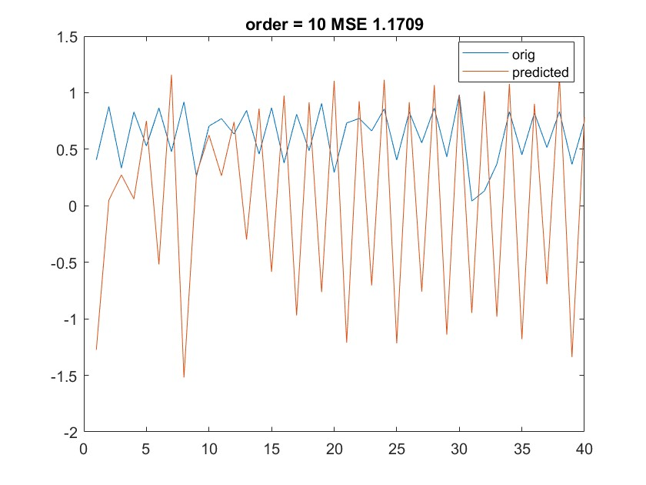

Figure 25: Prediction on the test set for order = 10

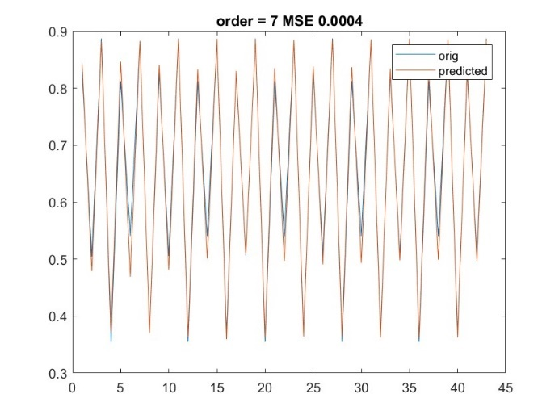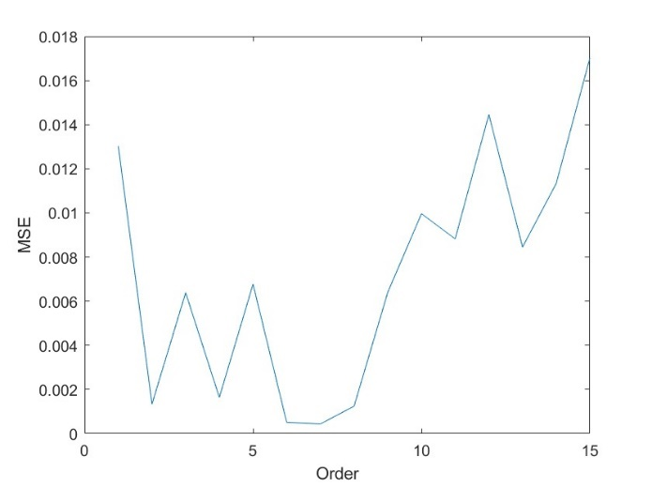

Figure 26: MSE as a function of order and prediction on the test set for order = 7

**2.6.2 Application: Santa Fe Laser Dataset**

The Santa Fe Laser data set is shown in Figure 29. The training set has 1000 points and the test set has 200 points.

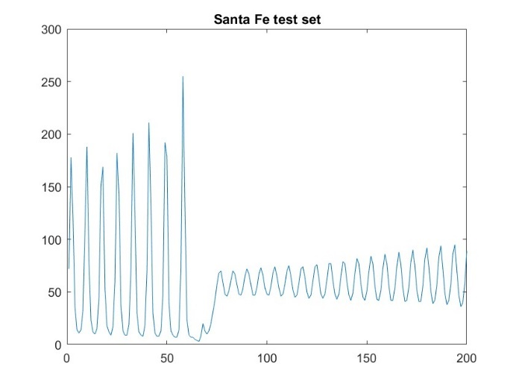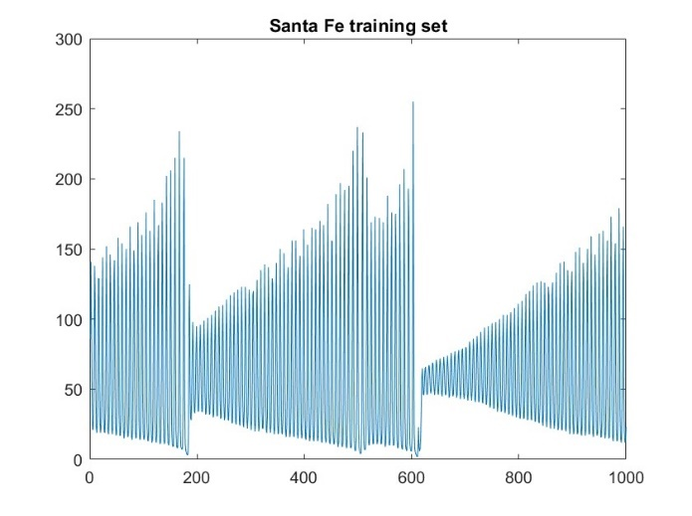

Figure 27: Santa Fe data set

First, we try to fit a model with order = 50. Again, we tune the parameters (γ and σ2) on the training set. The results are displayed in Figure 28. Prediction with order = 50 doesn’t capture the change of amplitude that occurs around point 15. From point 60, we also see that oscillations of the test set and the prediction are not in phase anymore. Therefore, order = 50 is not a good choice for the model.

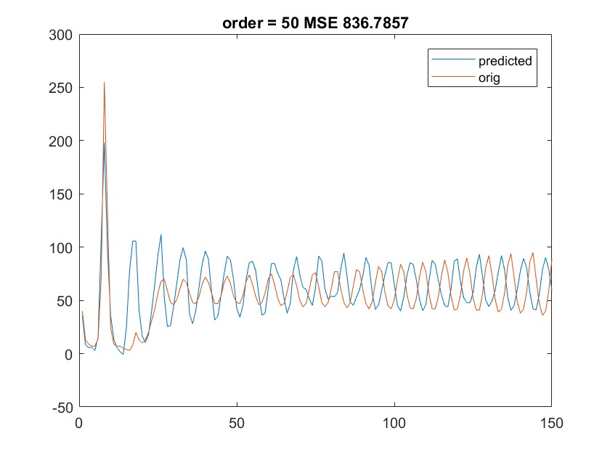

**Figure 28: Prediction on the test set for order = 50**

In the next step, we try different model orders on the test set and observe the mean squared error (MSE). The results are plotted in Figure 29. The best results are given for an order = 30. The difficulty with the test set is that around point 60, the amplitude of the oscillations change suddenly and it is difficult for the trained model to predict this change. We also noticed that the results of the tuning of the hyper-parameters are not very stable.

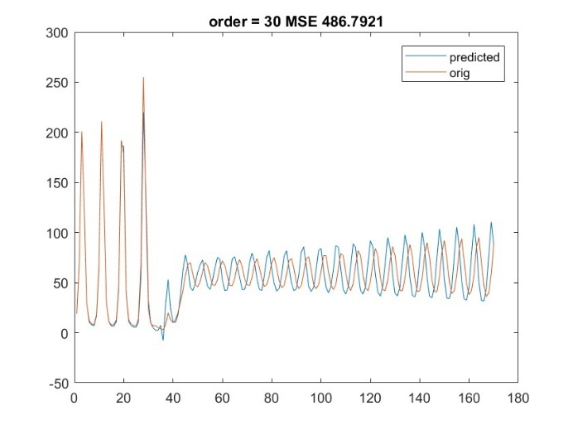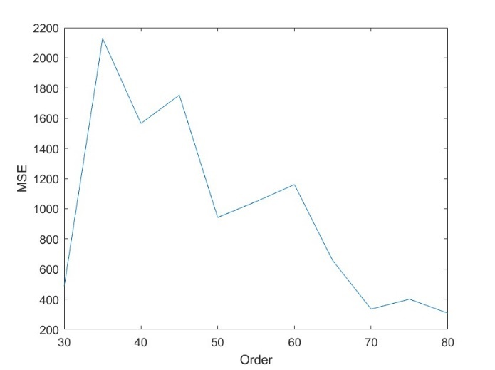

**Figure 29: Results of prediction for order = 30 and MSE as a function of order**

Other order (70, 80) gave interesting results, but the interpretation is flawed since for such orders, the sudden change of behavior lies then in the test sample to predict and is not part of the prediction.

It is not correct to use this test set to choose the model order and report the error on the same set. A separate validation set should be extracted from the training set and could be used to find the optimal model order. Alternatively, Bayesian ARD could be used to determine the order and select the most relevant inputs.